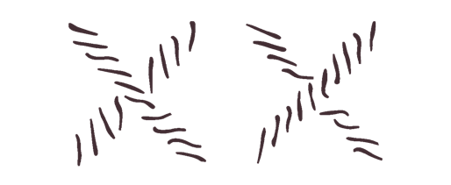
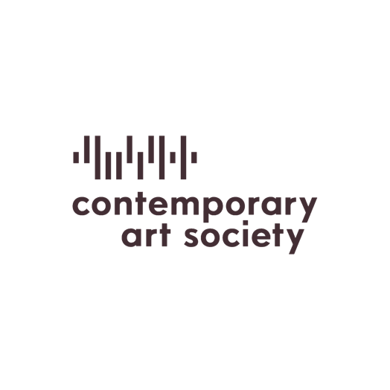

Valeria Napoleone XX
Contemporary Art Society
Call for Applications

Valeria Napoleone XX Contemporary Art Society (VN XX CAS) is a joint initiative of philanthropist Valeria Napoleone and the Contemporary Art Society. The purpose of the initiative is to support the acquisition of significant works by women artists for Contemporary Art Society Museum Members.

VN XX CAS acts as a focal point for debate on gender inequality in the arts. It intends to provoke an examination of collecting practice and the wider effect beyond the acquisition of the awarded work.

The initiative is open to all Contemporary Art Society Museum Members, and the successful applicant will make a strong case for addressing the representation of women artists within their existing collections. Deadline for applications is 2 May 2025, 10 a.m.

The successful museum will undertake a period of research supported by the Contemporary Art Society and Valeria Napoleone.
Museum Members considering applying to VN XX CAS are advised to arrange to speak personally with the curatorial staff at the Contemporary Art Society before submitting an expression of interest. More detailed application guidelines will be provided at this point.
To set up an appointment for a conversation with a member of Contemporary Art Society’s curatorial staff please contact assistant@contemporaryartsociety.org.

