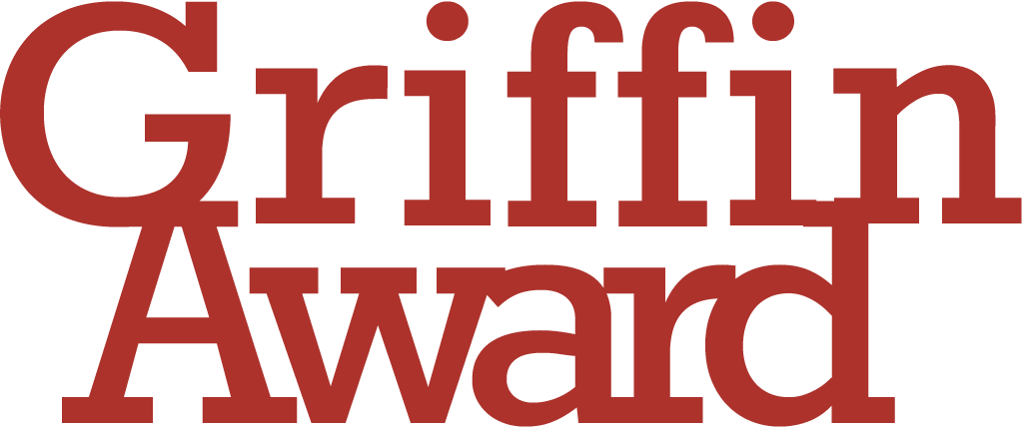

The Griffin Award is designed to support the acquisition or commission of an important work in a craft medium. The work acquired should play a major role in the museum’s existing collection, and applications are encouraged for work in all applied arts media including, but not limited to: ceramics, glass, metal, jewellery, textile, wood and lettering.
Contemporary Art Society Museum Members are invited to apply with a proposal to acquire work they consider will have a significant impact on their collections. Both UK and international artists/practitioners will be considered.
Deadline for applications is 3 May 2024, 10 am

How to apply

The deadline to apply to the Griffin Award is 3 May 2024, 10.00 am, for questions please contact Christine@contemporaryartsociety.org
Applications should be sent to specialprojects@contemporaryartsociety.org

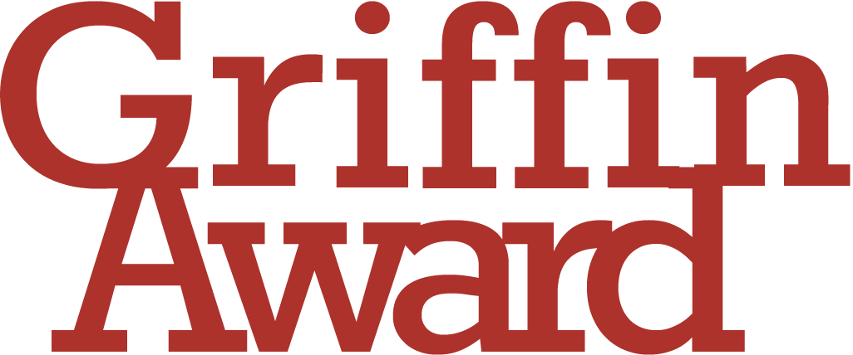

Application Form
Name of applicant:
Position within organisation:
Name of organisation:
Applicants are invited to make a case for the acquisition of a work by an artist of their choice. In composing your argument applicants are encouraged to consider the following questions:
- Describe how your chosen artist and their work connect to your existing collection, your city or region?
- How would a new acquisition through the Griffin Award benefit your audience?
- How would it develop research within the museum further? How would you use it to raise the profile of your museum nationally and internationally?
- Can you describe why the acquisition of a work through the Griffin Award would be of particular value now?

Please do not write more than 500 words.
The deadline to apply to the Griffin Award is 3 May 2024, 10.00 am.
Applications should be sent to specialprojects@contemporaryartsociety.org

