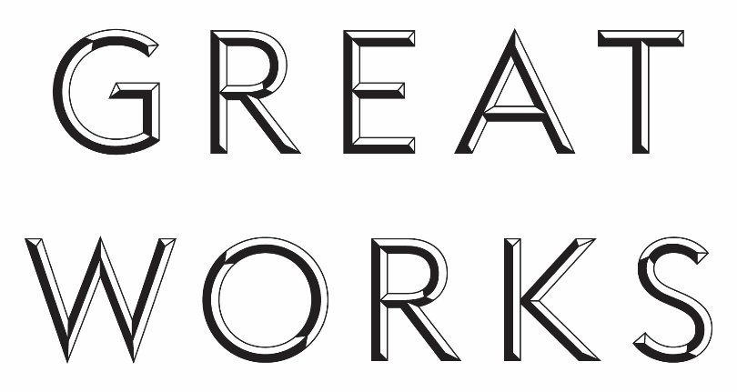

Call for Applications: Great Works supported by the Sfumato Foundation

The Contemporary Art Society invites applications from its Museum Members for the purchase of a work by a living British, or British-based artist of established international reputation. In particular, the successful applicant will make the case for the acquisition of work by an artist with a substantial connection to the museum’s existing collections, city or region. Recent Great Works acquisitions include: https://contemporaryartsociety.org/museums/special-projects/great-works
The deadline for applications will be 3 May 2024. The curatorial staff of the CAS will work together with the successful Museum Member, the artist and their gallery towards identifying the most appropriate work with the ambition of presenting this by the end of the financial year.
It is the overarching ambition of the Great Works scheme to ensure that major works of a calibre to match some of the great treasures of existing historical collections - and which might otherwise be inaccessible to museum audiences - enter public collections during the lifetime of the artist. The winning museum will make a strong case for how an acquisition of this scale would benefit the institution in relation to their audiences, scholarship and the profile of the Museum.
Contemporary Art Society Museum Members considering applying to the scheme are strongly advised to arrange to speak personally with a member of the curatorial staff at the CAS before submitting an expression of interest. More detailed application guidelines will be available at this point.
To set up an appointment for a conversation with a member of CAS’s curatorial staff please contact Christine Takengny, The Roden Senior Curator, Museums Acquisitions: Christine@contemporaryartsociety.org

Encouraging an appreciation and understanding of contemporary art by a wide audience and donating works by important and new artists to museums and public galleries across the UK.
Contemporary Art Society
59 Central Street
London EC1V 3AF
+44 (0)20 7017 8400
www.contemporaryartsociety.org

Contemporary Art Society is a company limited by guarantee. Registered in England and Wales no 255486
Charity Registration no 208178

Supported by

