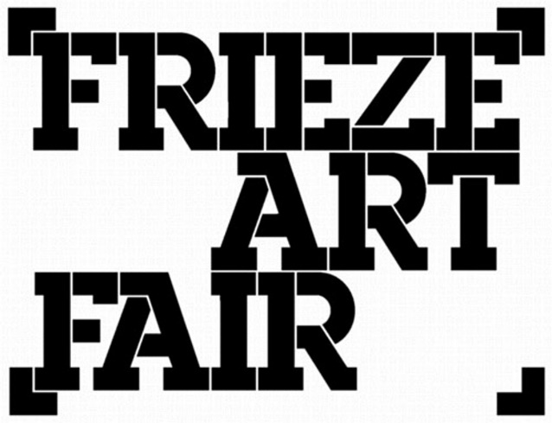

**Call for Applications:**

**Collections Fund at Frieze**

The Collections Fund at Frieze is a purchase prize, designed to acquire major work by living artists, addressing some of the most pressing issues of the day.

The CAS has partnered with Frieze London since 2015, and we are proud of a track record of timely acquisitions that includes outstanding artists such as John Akomfrah, Kader Attia, Zanele Muholi, Zadie Xa, Kehinde Wiley, Billie Zangewa, Ibrahim Mahama, Haegue Yang and Nour Jaouda.

The scheme is funded by a committee of CAS patrons, and draws together the knowledge, experience and expertise of private collectors with that of museum curators in a short and intense programme of research leading to an acquisition. The scheme provides curators with a framework for research, including studio visits and discussion with the members of the committee.

The Collection Fund at Frieze will support a Member Museum to purchase a significant work at **Frieze London/Frieze Masters 2025**. In addition to this, the Contemporary Art Society will provide a research bursary to support the curator’s travel and accommodation. Please note that all transport, crating and conservation costs must be covered by the museum.

**Who can apply?**

All Contemporary Art Society Museum Member are eligible to apply for the Collections Fund at Frieze. We will consider applications from single Member Museums, or partnerships between institutions. Only one successful application will be chosen each year.

**Criteria**

This is a scheme for those who are interested and available to undertake a short and intense programme of research in Summer and early Autumn that will result in the purchase of a significant work at **Frieze London/Frieze Masters 2025**. In writing the application, we are not looking for institutions to define exactly which artists or works they are interested in acquiring. Instead, we aim to identify artists whose work speaks vividly to the times we are living in. Applicants should describe how a work acquired through this scheme might connect with the current collecting and exhibition priorities of the museum.

The Collections Fund at Frieze will support acquisitions of British and international living artists working in any medium including film, performance, photography, sculpture and installation.

**Timeframe**

**2 May 2025:** Deadline for museums to submit an application.

**Between May and October 2025**: Research

**25 June 2025:** Curatorial team’s and Collections Fund at Frieze visit to the selected museum.

**October 2025:** A joint press release between the Contemporary Art Society, Frieze London/Frieze Mastersand the museum to announce the acquisition.

The successful candidate will be expected to work with us on audience evaluation processes.

**How to apply**

The deadline to apply to the Collections Fund at Frieze is **2 May 2025, 10:00 a.m.** Applications should be sent to [specialprojects@contemporaryartsociety.org](mailto:specialprojects@contemporaryartsociety.org?subject=CAS%20Artist%20Award%20at%20Frieze%20Application)

We recommend a preliminary conversation with colleagues considering making an application, please contact assistant[@contemporaryartsociety.org](mailto:christine@contemporaryartsociety.org?subject=CAS%20Artist%20Award%20at%20Frieze%20Application%20Conversation) to arrange a phone appointment with our curatorial team.